**Report on Email Analysis**

**Submitted by: Khalil Jibran**

**Dated: 6/3/2024**

**Submitted to: TechnoHacks EduTech**

**Objective: Take any email and analyze it, identify the red flags, and create a report on how to avoid such attacks.**



**Report on Email Analysis**

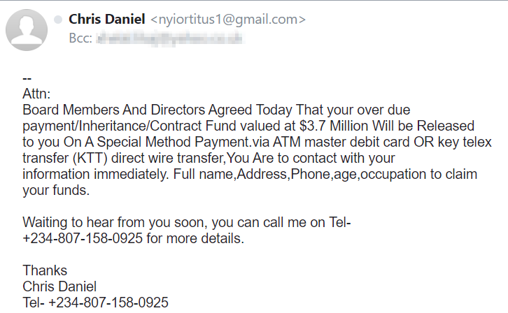

This is a report on a suspicious email that can be considered as a phishing email. 'Phishing' is when cyber criminals try scamming the victims for money using scam emails, text messages and phone calls. The aim is often to make you visit a website, which may download a virus onto your computer, or steal bank details or other personal information.

The above email has an email address which is not professional at all.

It does not match the name of the email sender.

Below, it has a typing error I.e Attention is written as Attn, a mistake which a professional person cannot make because it is so basic work ethic.

Moreover, the grammar and the sentence structure is also immature, you can see that there are certain capital letters used which have no need there.

The email states reasons like “payment/inheritance/contract” which means it is a spam email and is just typed to trick all types of bank users for money.

It has full stops used in a single sentence, which depicts poor grammar.It directly demands the info which can be used to hack the victims.

The number does not seem to be real as well and as the number is not real it means that the name is also fake.

The language if you see overall and the name, number, grammar, email and the information used is all poor and shows low standard professionalism. Which makes us easy to catch a cyber-criminal who aims to scam us for money or wants to destroy our reputation.